Math 9-B
Course Syllabus
2020
St. Malachy’s Memorial High School
D. Simard
Room 219
dan.simard@nbed.nb.ca
Mathematics 9B - Patterns and Relations
In this second Grade 9 mathematics course students will build on their numeracy skills from Mathematics 9A. Topics will include: powers, operations on powers, polynomials, operations on polynomials, patterns, linear relations and equations, and single variable linear inequalities.

Curricular Outcomes

Powers and Exponent Laws (N1 & N2)
- Demonstrate the understanding of powers with integral bases and whole number exponents by representing repeated multiplication using powers.
- Using patterns to show that a power with an exponent of zero is equal to one.
- Solving problems involving powers.
- Perform operations on powers with integral bases and whole number exponents (Exponential laws)
Polynomials (PR5, PR6 & PR7)
- Demonstrate an understanding of polynomials of degree less than or equal to 2.
- Model, record and explain the operations of addition and subtraction of polynomial expressions, concretely, pictorially and symbolically.
- Model, record and explain the operations of multiplication and division of polynomial expressions by monomials, concretely, pictorially and symbolically.
Linear Equations and Inequalities (PR3 & 4)
- Calulate the Rate of Change/Slope
- Briefly revisit scatter plots, correlation, and line-of-best-fit but extend to estimating equations of these lines
- Determine equation of a line.

Linear Relations (PR1 & PR2)
- Generalize a pattern arising from a problem-solving context using linear equations and verify by substitution.
- Graph linear relations, analyze the graph and interpolate or extrapolate to solve problems.

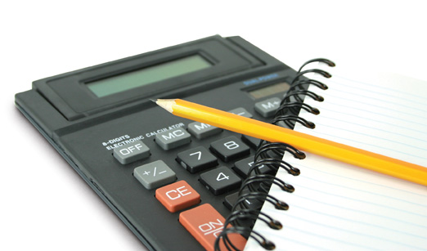 | GRADING  Powers & Exponents 20%  Polynomials 20%  Linear Equations & Inequalities 20%  Linear Relations 20%  Final Exam 20%

Assessment Policy

All summative assessments (assignments, quizzes, unit tests, exams) must be completed, with firm deadlines in place. If an assessment is missed, a zero will be added to PowerSchool until the assessment is complete. Missed assessments must be completed during lunch time. In class assignments will be collected and marked after the class they are given in. If students are dissatisfied with their mark or they did not have enough time to complete the assignment, they are welcome to come in during lunch to make corrections or complete the assignment.

Testing Policy

Students will be given reasonable notice of testing dates and test content at St. Malachy’s Memorial High School. All students are expected to write the test on the assigned day unless they have a written medical excuse from a doctor/parent. Should a student miss a scheduled test, the following steps will be taken in order that the marked test can be given back to all students in a timely fashion:

1. The test will be written upon the day of return to school either in class (where appropriate) or during the lunch hour.

2. Where a student misses the allotted make up time with their classroom teacher, they will be expected to attend a test re-write session with an administrator in Room 110 on the following day.

3. Any student who misses the opportunity to write the test on these three occasions will meet with an administrator and disciplinary action will be taken.

